### A REPORT ON

Emotion Detection (EmoDec)

SUBMITTED IN PARTIAL FULFILLMENT FOR AWARD DEGREE OF

### BACHELOR OF ENGINEERING

IN

Information Technology

BY

Harshit Verma ()



### DEPARTMENT OF INFORMATION TECHNOLOGY

**UIET, PANJAB UNIVERSITY SSG REGIONAL CENTRE,**

**HOSHIARPUR-146021, Punjab (INDIA)**

**(2021-2022)**

**CERTIFICATE**

Certified that the training report entitled “Emotion Detection (EmoDec)” submitted by **Harshit Verma** (), student of B.E. (I.T), UIET, Panjab University Swami Sarvanand Giri Regional Centre, Hoshiarpur, in the partial fulfillment of the requirement for the award of Bachelor of Engineering (Information Technology) Degree of Panjab University, Chandigarh is a record of student’s own study carried under my supervision & guidance.

This report has not been submitted to any other university or institution for the award of any degree.

Training Incharge

# DECLARATION

The work embodied in the training report entitled, **“**Emotion Detection (EmoDec)**”** submitted to the department of Information Technology at UIET, Panjab University Swami Sarvanand Giri Regional Centre, Hoshiarpur for the award of degree of Bachelor of Engineering, has been done by me. The training report is entirely based on my own work and not submitted elsewhere for the award of any other degree. All ideas and references have been duly acknowledged.

### Harshit Verma

**Countersigned by:**

**CONTENTS**

|  |  |  |  |
| --- | --- | --- | --- |
|  | | |  |
| **S.No.** |  | **Title** | **Page No.** |
| 1 | Certificate |  | 2 |
| 2 | Declaration |  | 3 |
| 3 | Contents |  | 4 |
| 4 | Abstract |  | 5 |
| **Chapter 1** | **Introduction** |  | 6 |
| 1.1 | Deep Learning |  | 6 |
| 1.3 | Technologies |  | 7 |
| 1.4 | Requirements |  | 8 |
| 1.5 | Steps to create project |  | 9 |
| **Chapter 2** | **EmoDec** |  | 10-19 |
| 2.1 | Creating Jupiter notebook |  | 10 |
| 2.2 | Training machine learning model |  | 11-12 |
| 2.3  **Chapter 3** | Creating GUI for machine learning model |  | 13-16 |
| 3.1 | Final Results |  | 17-18 |
| 3.2 | Conclusion, Future Scope, References |  | 18-19 |

**Abstract**

The automatic recognition of emotions has been an active research topic from early eras. Therefore, there are several advances made in this field. Emotions are reflected from speech, hand and gestures of the body and through facial expressions. Hence extracting and understanding of emotion has a high importance of the interaction between human and machine communication. This project describes the advances made in this field and the various approaches used for recognition of emotions. The main objective of the project is to propose real time implementation of emotion recognition system.

This project implements the application of feature extraction of facial expressions with combination of neural network for the recognition of different facial emotions (happy, sad, angry, fear, surprised, neutral etc..). Humans are capable of producing thousands of facial actions during communication that vary in complexity, intensity, and meaning.

Purposed system depends upon human face as we know face also reflects the human brain activities or emotions.

**Introduction**

Detecting human emotions like angry, fear, happy with the help of machine learning (Deep Learning) and generating respective emoji.

We will use deep learning to detect human emotions from images. We will classify human facial expressions to filter and map corresponding emojis or avatars with the help of neural networks. To achieve this we would be using tensorflow and keras libraries.

**Deep Learning**

It is a subfield of machine learning concerned with algorithms inspired by the structure and function of the human brain. Deep learning algorithms attempt to draw similar conclusions as humans would by continually analyzing data with a given logical structure. To achieve this, deep learning uses a multi-layered structure of algorithms called neural networks.

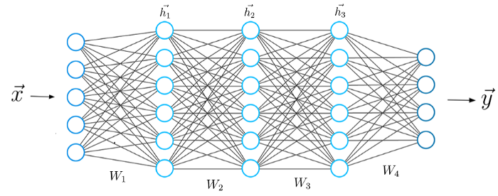A typical Neural Network

**Data Set**

For this project we are going to use data set from Kaggle. [FER-2013 | Kaggle](https://www.kaggle.com/msambare/fer2013)

The data consists of 48x48 pixel grayscale images of faces. The faces have been automatically registered so that the face is more or less centred and occupies about the same amount of space in each image.

The task is to categorize each face based on the emotion shown in the facial expression into one of seven categories (0=Angry, 1=Disgust, 2=Fear, 3=Happy, 4=Sad, 5=Surprise, 6=Neutral).

The training set consists of 28,709 examples and the public test set consists of 3,589 examples.

**Technologies and Requirements**

1. Python
2. Visual Studio Code
3. Numpy
4. Tensorflow
5. Keras
6. OpenCV
7. Intel i5 or above CPU and a GPU for processing large amount of image data.

******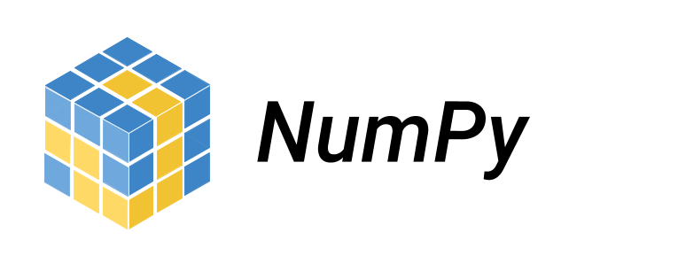**

* **Python -** Python is an interpreted high-level general-purpose programming language. Python plays a vital role in AI coding language by providing it with good frameworks like scikit-learn: machine learning in Python, which fulfils almost every need in this field.
* **Visual Studio Code -** Visual Studio Code is an Integrated Development Environment (IDE) made by Microsoft for Windows, Linux and macOS. Features include support for debugging, syntax highlighting, intelligent code completion, snippets, code refactoring, and embedded Git. Users can change the theme, keyboard shortcuts, preferences, and install extensions that add additional functionality.
* **Numpy –** It is a library for the Python programming language, adding support for large, multi-dimensional arrays and matrices, along with a large collection of high-level mathematical functions to operate on these arrays.
* **Tensorflow -** TensorFlow is a free and open-source software library for machine learning and artificial intelligence. It can be used across a range of tasks but has a particular focus on training and inference of deep neural networks. Tensorflow is a symbolic math library based on dataflow and differentiable programming. It is used for both research and production at Google.
* **Keras -** It is an open-source software library that provides a Python interface for artificial neural networks. Keras acts as an interface for the TensorFlow library. Keras contains numerous implementations of commonly used neural-network building blocks such as layers, objectives, activation functions, optimizers, and a host of tools to make working with image and text data easier to simplify the coding necessary for writing deep neural network code.
* **OpenCV –** It is a library of programming functions mainly aimed at real-time computer vision. Originally developed by Intel. OpenCV is the huge open-source library for the computer vision, machine learning, and image processing and now it plays a major role in real-time operation which is very important in today’s systems. By using it, one can process images and videos to identify objects, faces, or even handwriting of a human.

**Steps to create project**

1. Creating a python script named as train.py.
2. Importing relevant libraries such as numpy, keras.
3. Initialize the training and validation generators.
4. Build the convolution network architecture.
5. Compile and train the model.
6. Save the model weights.
7. Using openCV haarcascade xml detect the bounding boxes of face in the webcam and predict the emotions.
8. Creating a python script named as gui.py.
9. Creating a folder named emojis.
10. Saving the emojis corresponding to each of the seven emotions in the dataset.
11. Using camera to detect the emotions in real time and generating relevant emojis with it.

**EmoDec**

**Creating Jupiter notebook**

**Creating “train.ipynb”** for training our machine learning model.

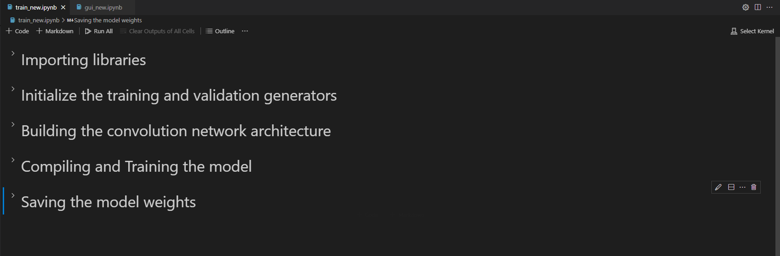

**Creating “gui.ipynb”** for creating user interface of our machine learning model.

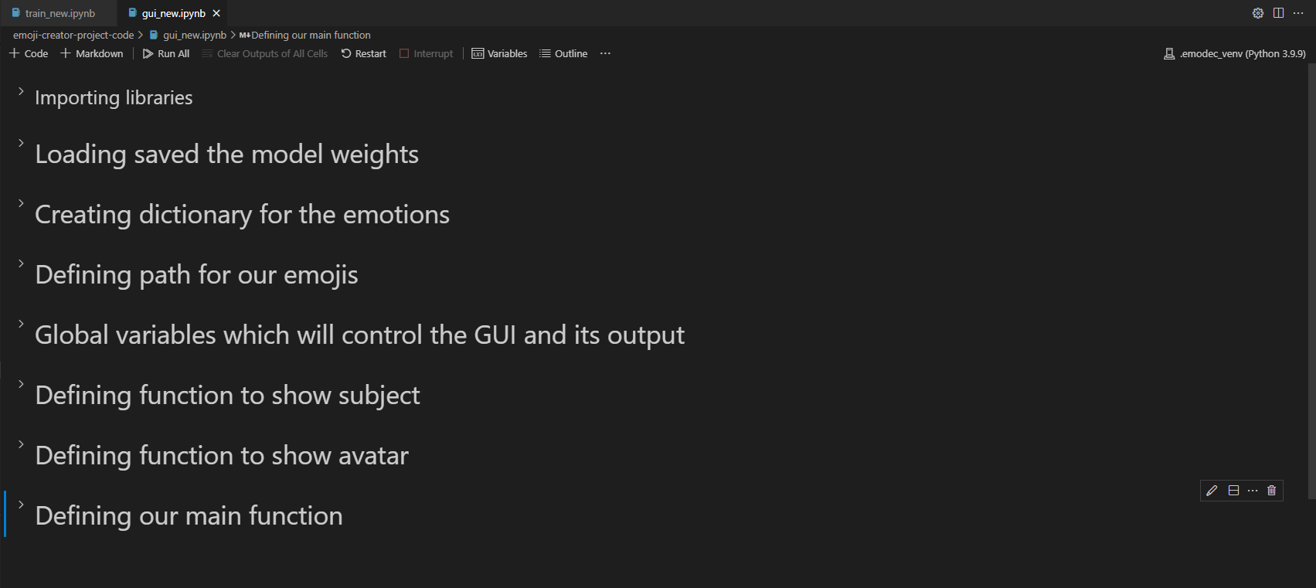

**Training machine learning model**

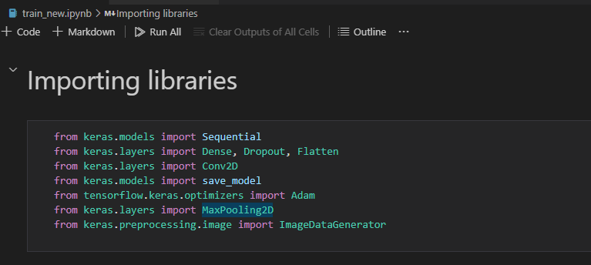Importing necessary libraries.

Initialize the training and validation generators

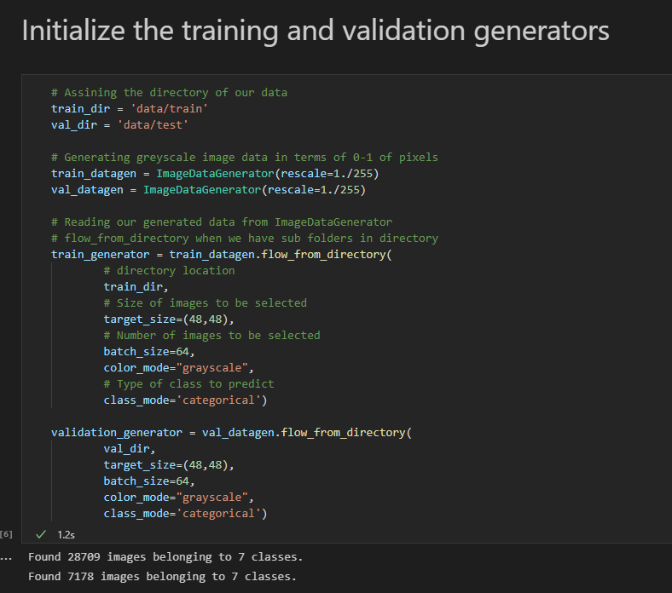

Building our neural network.

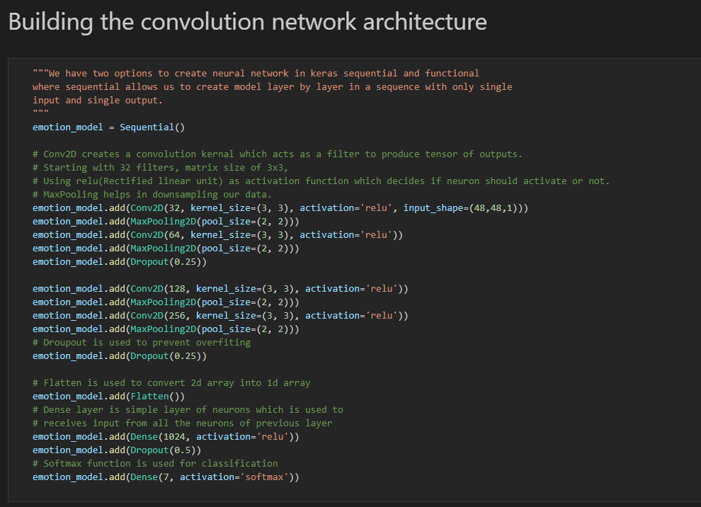

Compiling our neural network.

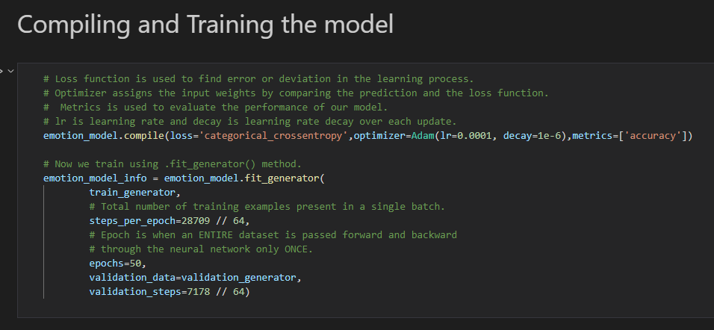

**Creating GUI for machine learning model**

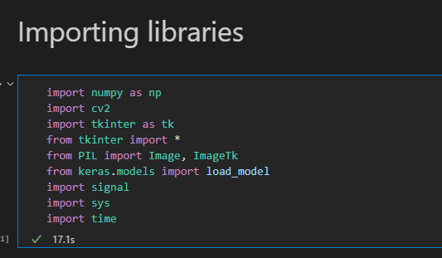Importing necessary libraries.

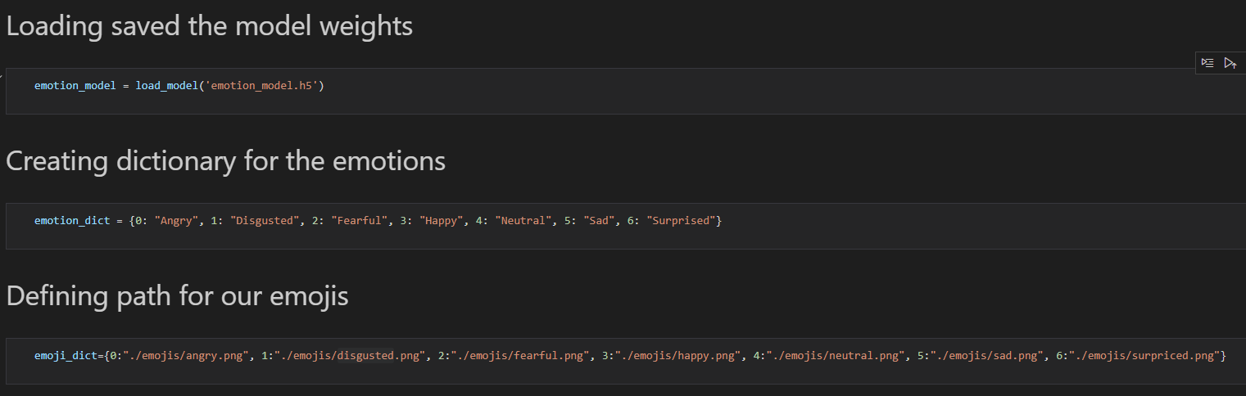Loading model and defining path for emojis

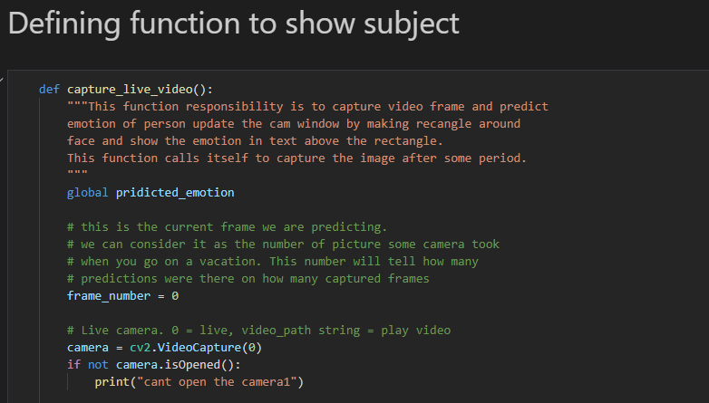Defining function to show subject

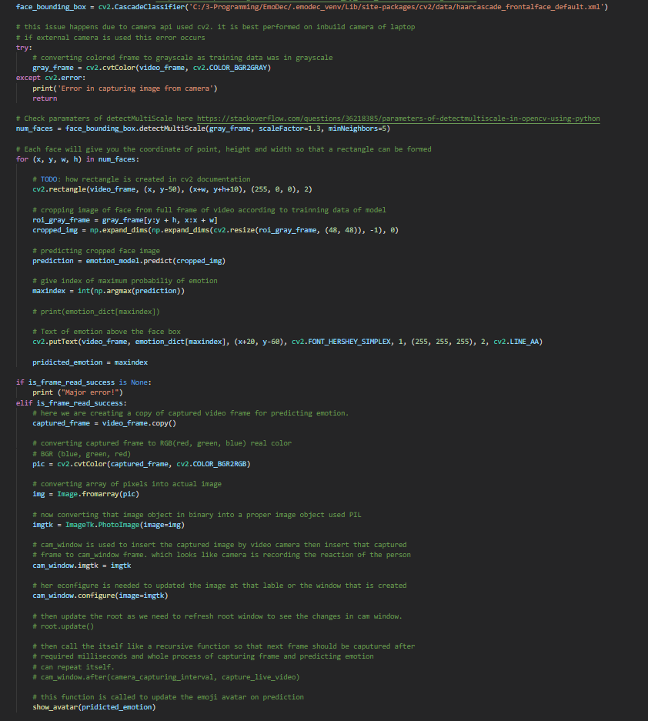

This our function to show subject (which will be us) in the GUI. With this function a window will open which will either run a live cam feed or will run a previously saved video as specified in the code.

Defining function to show avatar

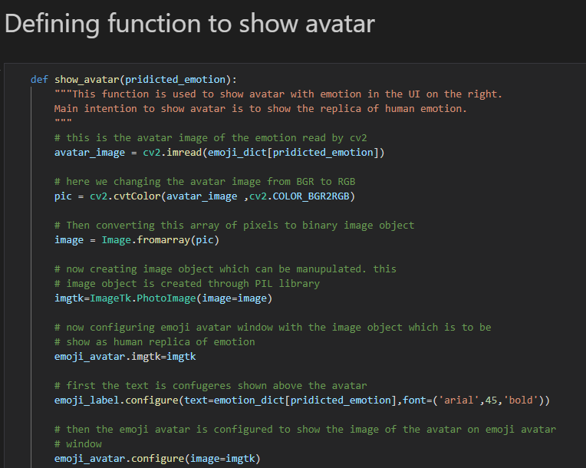

Defining our main function.

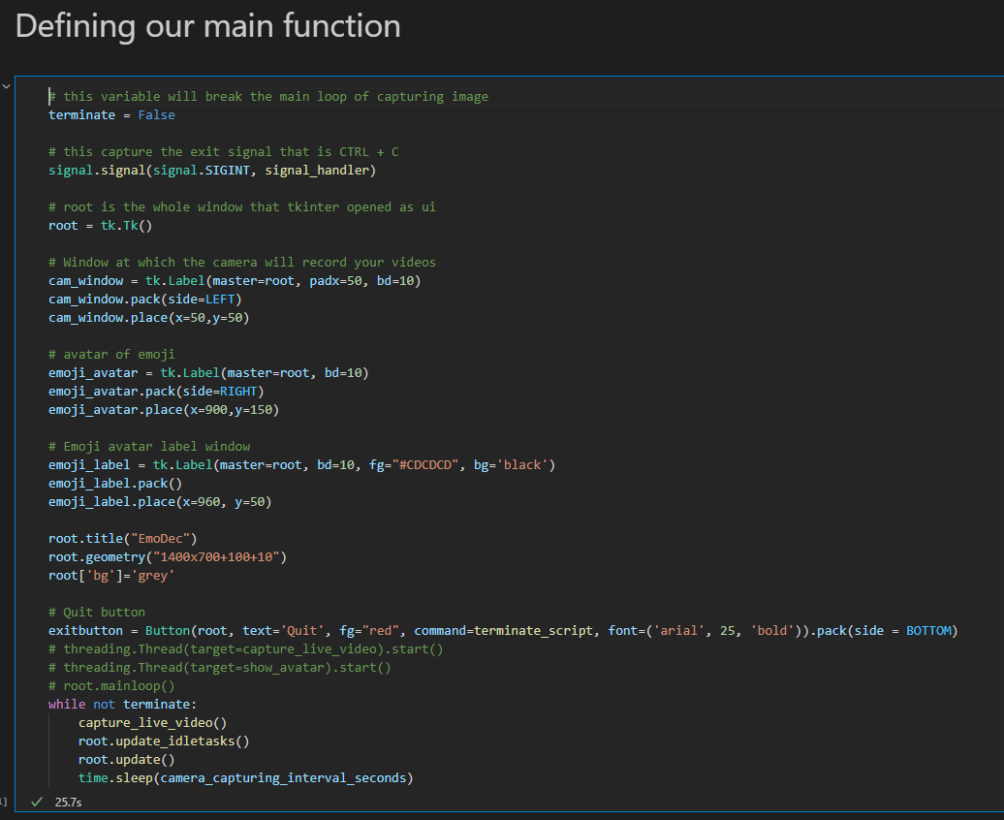

**Final Result**

Happy

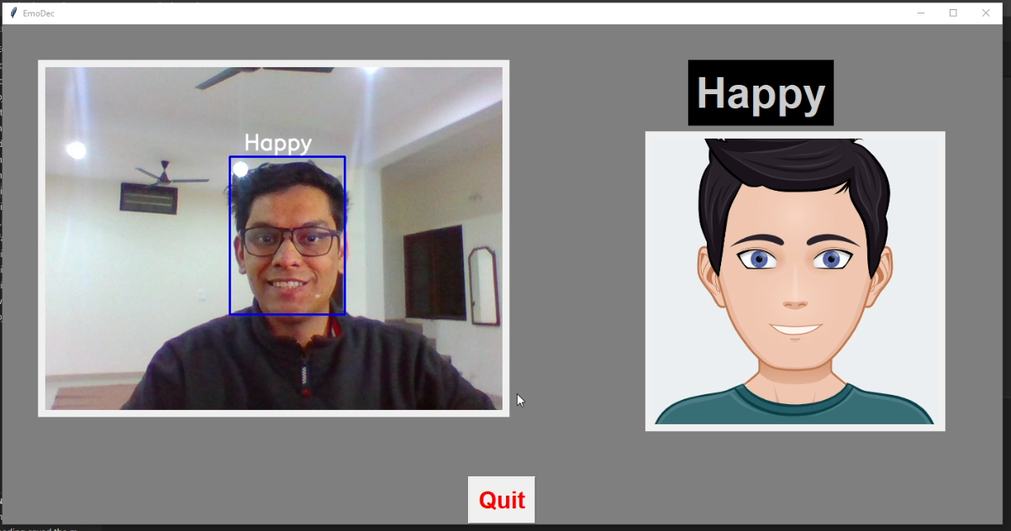

Surprised

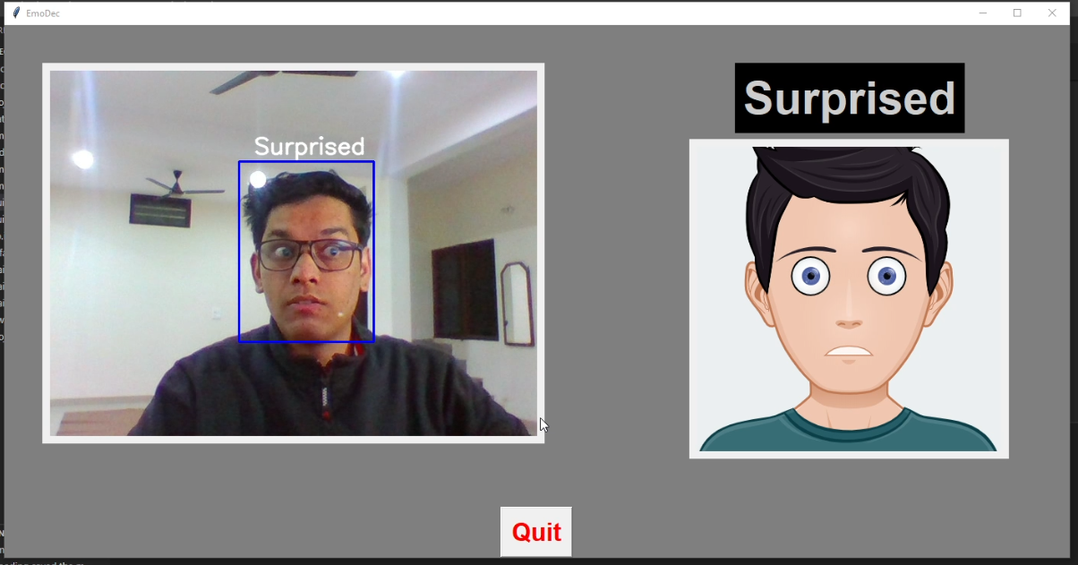

**GIF of the results**

**Conclusion**

In this project, we tried to classify facial emotions over static facial images using deep learning techniques. The face detection and emotion recognition are very challenging problems. They require a heavy effort for enhancing the performance measure of face detection and emotion recognition. This area of emotion recognition is gaining attention owing to its applications in various domains such as gaming, software engineering, and education.

Our project had one major limitation: the lack of an extensive dataset of emotions. For instance, we used a dataset containing 28,709 images. By having a larger dataset, we could improve our results.

Thus, with the help of Google’s Tensorflow and implementation of deep neural network we were able to classify human emotions with image data.

**Future Scope**

**Deepfake Detection**

Academic research into identifying deepfake video manipulations ramped up in the 12 months prior to the 2020 US election, in response to widely-voiced concerns around deceptive video content with a political agenda.

**Medical Research into Autism**

Machine learning systems for facial emotion recognition are particularly suited for the study of autism spectrum disorder (ASD), where sufferers have developmental and long-term difficulties in evaluating facial emotions.

**Automotive Safety and Research Systems**

Due to increased controversy over data mining and privacy concerns over the last five years, the diffusion and extent of always-on driver monitoring systems has hit a number of roadblocks relative to press exposure and anticipation around such technologies.

**Recruitment**

The rise of teleconferencing-based interaction since the advent of COVID-19 solves two major obstacles to using FER in a recruitment interview context: the negative effects of explicitly training a camera on someone you are talking to (solved by the user's webcam); and the more recent challenge of the subject's face being occluded by a mask and thus hindering intelligent video analysis.

**References**

[www.Google.com](http://www.Google.com)

[www.YouTube.com](http://www.YouTube.com)

[www.geeksforgeeks.org](http://www.geeksforgeeks.org)

[www.tutorialspoint.com](http://www.tutorialspoint.com)

<https://docs.python.org>

<https://keras.io>

<https://towardsdatascience.com>

[www.stackoverflow.com](http://www.stackoverflow.com)

<https://docs.opencv.org>

<https://www.pyimagesearch.com>